**13/04/2022**

**Q1)Write a program to implement trigger.**

**CODE**

create database dwany;

use dwany;

create table new_employee(emp_id int(10),emp_name varchar(20),emp_department varchar(20));

create table mca_dept(emp_id int(10),emp_name varchar(20),mca_dept varchar(20));

create table cs_dept(emp_id int(10),emp_name varchar(20),cs_dept varchar(20));

insert into new_employee values(1,"dwany","MCA");

insert into new_employee values(2,"anil","CS");

insert into new_employee values(1,"Anika","MCA");

insert into new_employee values(2,"Malavika","CS");

select * from new_employee;

select * from mca_dept;

select * from cs_dept;

**TRIGGER**

CREATE DEFINER=`root`@`localhost` TRIGGER `new_employee_AFTER_INSERT` AFTER INSERT ON `new_employee` FOR EACH ROW BEGIN

if(new.emp_department='MCA') then

insert into mca_dept set

emp_id=new.emp_id,emp_name=new.emp_name,mca_dept="Asst.Prof filled";

end if;

if(new.emp_department='CS') then

insert into cs_dept set

emp_id=new.emp_id,emp_name=new.emp_name,cs_dept="Asst.Prof filled";

end if;

END

**OUTPUT**

new_employee TABLE

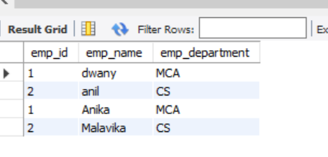

mca_dept TABLE

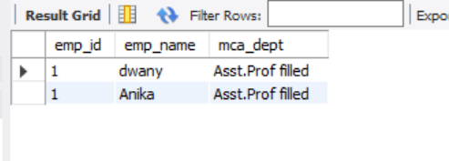

cs_dept TABLE

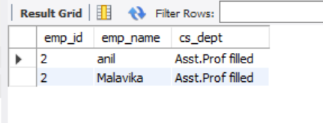

**Q2) Write a program to implement cursor.**

**CODE**

create database college;

use college;

create table library (shelf_no int(10),category varchar(10),book_name varchar(20));

insert into library values(11,'science','algebra');

insert into library values(12,'science','Data Mining');

insert into library values(21,'comic','New Avengers');

insert into library values(22,'comic','Spiderman');

insert into library values(31,'drama','romeo and juliet');

insert into library values(32,'drama','hamlet');

create table book_by_order(book_shelf int (10),book_category varchar(20),bookname varchar(20));

select * from library;

drop table book_by_order;

drop table library;

call book_details();

select * from book_by_order;

**cursor code**

CREATE DEFINER=`root`@`localhost` PROCEDURE `book_details`()

BEGIN

declare book_shelf int(10);

declare bookname varchar(20);

declare book_category varchar(10);

declare C_finished integer default 0;

declare C1 cursor for select shelf_no,category,book_name from library;

declare continue handler for NOT FOUND set C_finished=1;

open C1;

book_details:loop

if C_finished =1 then

leave book_details;

end if;

if C_finished =0 then

Fetch from C1 into book_shelf,book_category,bookname;

if book_category='comic' then

insert into book_by_order values(book_shelf,bookname,book_category);

end if;

end if;

end loop;

close C1;

END

**OUTPUT**

Library table

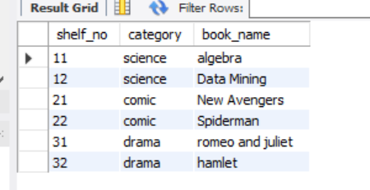

Book_by_order Table

